CSC 4350: Software Engineering

Fall 2016 Semester

September 18, 2016

Document # 2 – Requirement Elicitation

Team 6 – Bookkeeper Web Application

Anthony Jones

McKenzie Rochester

Daniel Campbell

Jeff Sikala

Jordan Smith

**Problem Statement**

Bookkeeper is a two-part web application for college students. The first part is to allow users to contact each other in order to privately sell/buy/trade books for courses offered at a student’s specific university. The second part is to allow a forum-like discussion page for each course for students to give advice, or a way to communicate with other students who have previously taken the course.

Upon opening the home page of Bookkeeper, the user shall be prompted to log in using their email and password. If the user does not have an account, then the user shall be prompted to create one. Bookkeeper shall retain the user’s information after they have logged in to their account. The application will take the user to their account page, where they can view their book postings and messages.

The web app shall have a search menu, allowing them to search for their specific major, and courses. If the student has a book to sell, he or she shall be able to fill out a form, giving all the information they need to verify a book to sell. The web application shall allow users to communicate with each other in order to facility their private trade or sell. Bookkeeper will not handle any monetary transactions.

The web app shall allow students to discuss topics within the class, ask questions, or arrange meetups within their forums. The forums will be associated by course or by major. If the user clicks the logout option on the application, the application shall allow the user to successfully log out and delete any credential information form their web browser.

**Requirements Trace Matrix (RTM)**

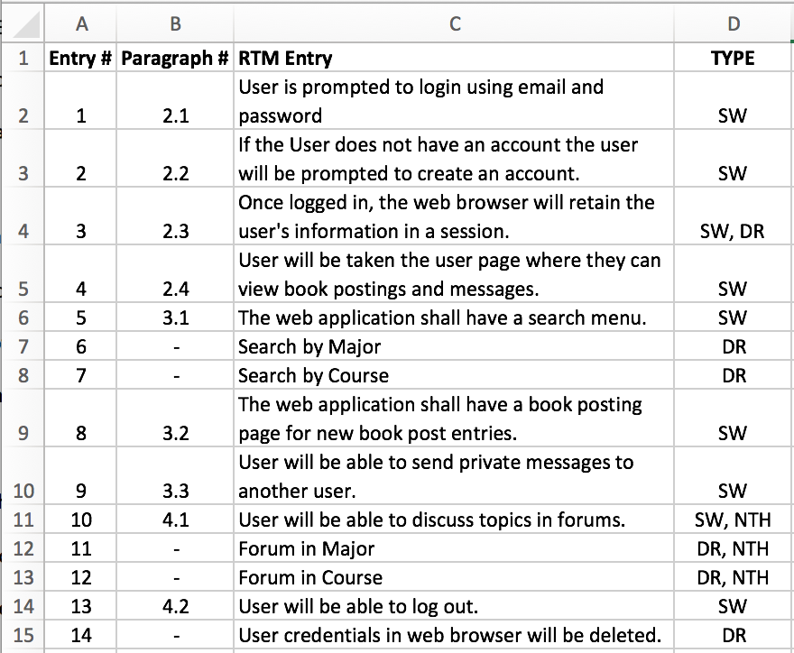

**Project Timeline (Gantt Chart)**

**Timeline is up to September 18, 2016**

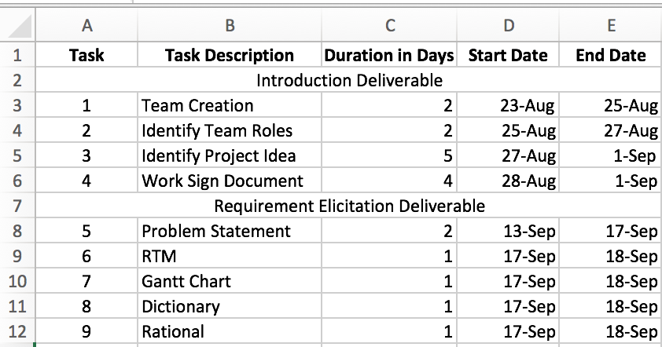

**Terminology**

* Web Application: A client server software application in which the client runs in a web browser.
* App: Short for application.
* Web Browser: A software application for retrieving, presenting, and traversing informational resources on the world wide web.
* Course: A class that is offered by a university or college.
* Web Browser Credentials: Information that is temporarily stored within the web browser in order to keep a user logged into the system for a period of time.
* Forum: A website where people can hold online conversations in the form of text messages.

**Rational**

Bookkeeper is an application that is designed to allow students within their local area to be able to sell books to another student by direct contact. Currently students have limited options to sell back their expensive books that they have purchased over school semesters. Students are only left with either selling their books to online stores such as Amazon and Chegg, or they are left selling back their books to the local bookstore for a very low price. We are providing a way for students to get back a good portion of their money by offering a way for students to communicate with each other to sell books privately. Bookkeeper does not facilitate in any sales, rather it gives users the ability to post and communicate with each other.

As an added benefit, users will be able to post advice or any other information on forums by either course or major. It is another avenue for students to be able to engage in their college communities and to be able help an encourage their fellow students.